Project Development phase - 1

Preprocessing Steps and Business Questions with visualization
Date | 8 July 2026
Team ID | SWTID-2026-5839
Project Name | Visualizing Housing Market Trends: An  Analysis of Sale Prices and Features using Tableau
Maximum Marks

Data Preprocessing Steps
Step 1: Import the Dataset
- Imported the housing dataset into Tableau.
- Verified that all fields (Sale Price, Bedrooms, Bathrooms, Flat Area, etc.) were loaded correctly.
Step 2: Check for Missing Values
- Examined the dataset for null or blank values.
- Missing values were removed or handled appropriately to avoid incorrect analysis.
Step 3: Remove Duplicate Records
- Checked for duplicate house records.
- Removed duplicate entries to ensure every house was counted only once.
Step 4: Validate Data Types
- Ensured:
  - Sale Price → Number of FlatArea → Number of Age of House → Number of Years Since Renovation → Number of Latitude & Longitude → Geographic fields o Renovation Status → Categorical field Step 5: Verify Data Consistency
- Checked for unrealistic values such as:
  - Negative sale prices of Negative house age of Zero or invalid area values
- Corrected or removed inconsistent records.
Step 6: Prepare Calculated Fields
Created calculated fields where required, such as:
- Average Sale Price
- Count of Houses
- Total Sales by Renovation Years
- House Age Categories (if required) etc.
Step 7: Final Clean Dataset
After preprocessing, the dataset became ready for visualization and dashboard development in Tableau.

Business Question with Visualization

S.NO. | Business Question | Visualization
1. | How many housing records are available for analysis after data preprocessing? | Count of Transformed Housing Data
2. | What is the average sale price of houses in the dataset? | Average Sale Prices
3. | How is the basement area distributed among houses? | Area of House from  Basement (in Sqft)
4. | How do house sales vary based on the number of years since renovation? | Total Sales by Years Since  Renovation
5. | How does the age of houses differ between renovated and non-renovated properties? | Distribution of House Age by  Renovation Status
6. | How is house age related to the number of bedrooms, bathrooms, and floors? | House Age Distribution by  Number of Bathrooms,  Bedrooms, and Floors
7. | How does the Living Area show Impact on Sale Price | Impact of Living Area on Sale Price
8. | How does condition of house and view points show impact on sales price | Average Sale Price by Condition and View

3. Visualizations:
Count of Transformed Housing Data

Average Sale Prices
Area of House from Basement (in Sqft)
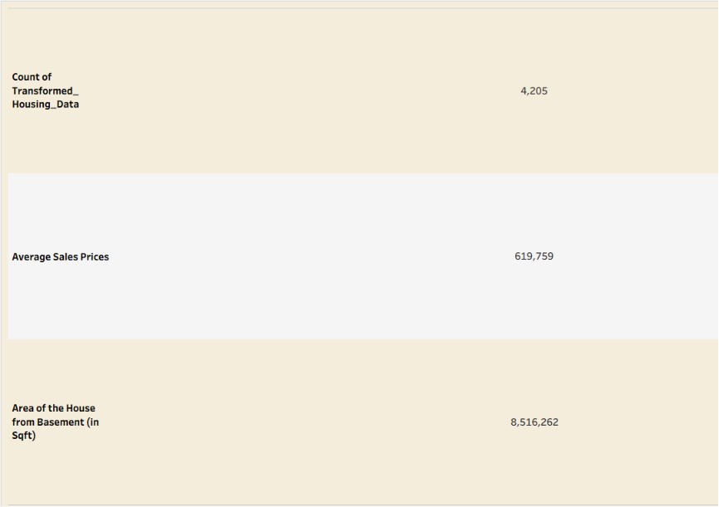

Total Sales by Years Since Renovation
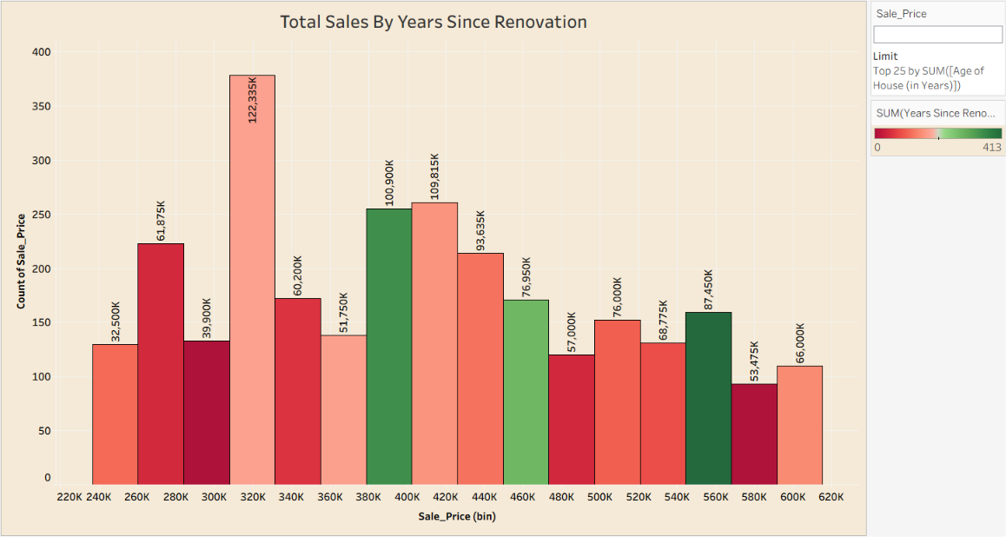

Distribution of House Age by Renovation Status

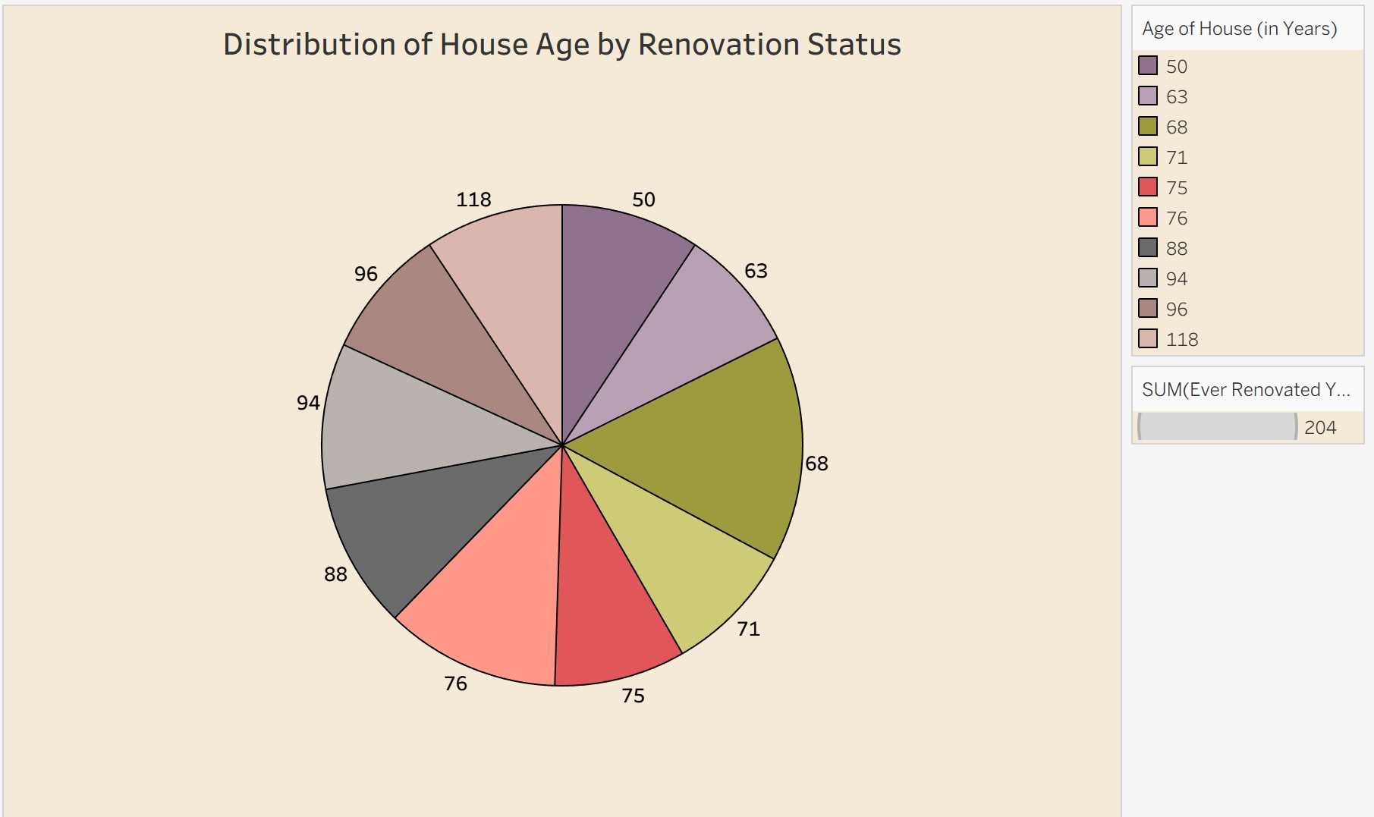

House Age Distribution by Number of Bathrooms, Bedrooms, and Floors
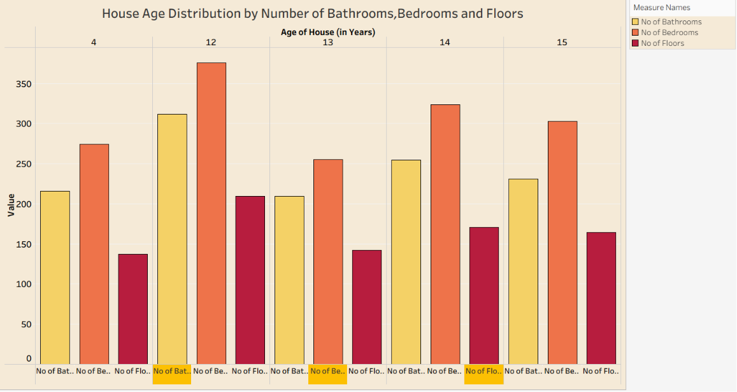

Impact of Living Area on Sale Price 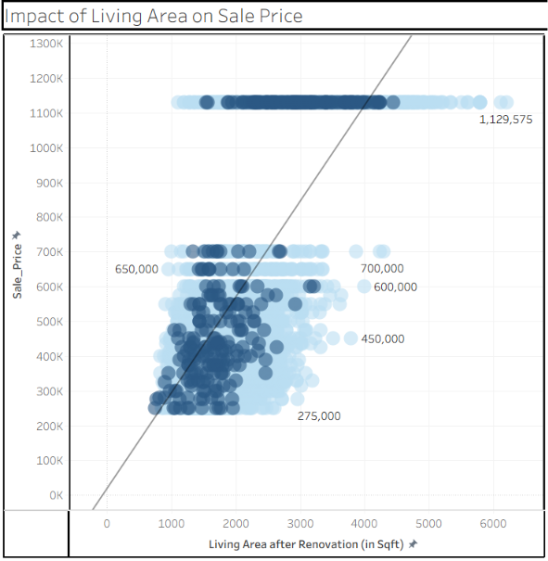

Average Sale Price by Condition and View
